# 4-Point Inspection Form

Insured/Applicant Name: Mr. ABC Application / Policy #: 6293CGg267

Address Inspected: 1345 Marseille Dr, Miami Beach FL 33141

Actual Year Built: 1949 Date Inspected: 12/20/2021



**Minimum Photo Requirements**

Dwelling: Each side  Roof: Each slope  Plumbing: Water heater, under cabinet plumbing/drains, exposed valves  Main electrical service panel with interior door label

 Electrical box with panel off

 **All hazards or deficiencies noted in this report**

**A Florida-licensed inspector must complete, sign and date this form.**

Be advised that Underwriting will rely on the information in this sample form, or a similar form, that is obtained from the Florida licensed professional of your choice. This information only is used to determine insurability and is not a warranty or assurance of the suitability, fitness or longevity of any of the systems inspected.

|  |  |  |  |  |  |  |  |
| --- | --- | --- | --- | --- | --- | --- | --- |
| **Electrical System**  Separate documentation of any aluminum wiring remediation must be provided and certified by a licensed electrician. | | | | | | | |
| **Main Panel**  Type:  Circuit breaker Fuse Total Amps: 125 |  |  | | **Second Panel**  Type:  Circuit breaker Fuse Total Amps: 125 | |  |  |
| Is amperage sufficient for current usage? | Yes | No (explain) | | Is amperage sufficient for current usage? | | Yes | No (explain) |
| **Indicate presence of any of the following:**  Cloth wiring  Active knob and tube  Branch circuit aluminum wiring (If present, describe the usage of all aluminum wiring):  * If single strand (aluminum branch) wiring, provide details of all remediation. *Separate documentation of all work must be provided.*  Connections repair via COPALUM crimp Connections repair via AlumniConn | | | | | | | |
| **Hazards Present** | | | |  | | | |
| Blowing fuses Tripping breakers Empty sockets Loose Wiring Improper grounding Corrosion  Over fusing | | | | Double taps Exposed wiring Unsafe wiring  Improper breaker size Scorching  Other (explain) | | | |
| **General condition of the electrical system:** Satisfactory  Unsatisfactory **(explain)**  Double tapped breaker was noted in the secondary electric panel breaker number nine. | | | | | | | |
| Supplemental information | | | | | | | |
| **Main Panel** | | | **Second Panel** | | **Wiring Type**  Copper  NM, BX or Conduit | | |
| Panel age: | | | Panel age: | |
| Year last updated: | | | Year last updated: | |
| Brand/Model: General Electric | | | Brand/Model: General Electric | |

A1 Florida Home Inspections 12/20/2021



# 4-Point Inspection Form

|  |
| --- |
| **HVAC System** |
| Central AC: Yes No Central heat: Yes No  If not central heat, indicate **primary** heat source and fuel type:  Are the heating, ventilation and air conditioning systems in good working order?  Yes No (explain)  Date of last HVAC servicing/inspection: |
| **Hazards Present**  Wood burning stove or central gas fireplace*not*professionally installed? Yes  No Space heater used as primary heat source? Yes  No  Is the source portable? Yes  No  Does the air handler/condensate line or drain pan show any signs of blockage or leakage, including water damage to the surrounding area?  Yes  No |
| Supplemental Information |
| Age of system: 5  Year last updated: 2016  (Please attach photo(s) of HVAC equipment, including dated manufacturer’s plate) |

|  |  |  |  |  |  |  |
| --- | --- | --- | --- | --- | --- | --- |
| **Plumbing System** | | | | | | |
| Is there a temperature pressure relief valve on the water heater? Is there any indication of an active leak? Yes  No  Is there any indication of a prior leak? Yes  No Water heater location: Exterior utility closet | Yes | No |  |  |  |  |
| **General condition of the following plumbing fixtures and connections to applicances:** | | | | | | |
| Satisfactory Unsatisfactory | N/A |  | Toilets Sinks  Sump pump  Main shut off valve All other visible | Satisfactory | Unsatisfactory | N/A |
| Dishwasher |  |  |
| Refrigerator |  |  |
| Washing Machine |  |  |
| Water Heater |  |  |
| Showers/Tubs |  |  |
| **If unsatisfactory, please provide comments/details (leaks, wet/soft spots, mold, corrosion, grout/caulk, etc.).** | | | | | | |
| Supplemental Information | | | | | | |
| Age of Piping System:  X Original to home  Completely re-piped  Partially re-piped  (Provide year and extent of renovation in the comments below) | | | **T ype of pipes (check all that apply)** | | | |
| Copper | | | |
| PVC/CPVC | | | |
| Galvanized | | | |
| PEX | | | |
| Polybutylene | | | |
| Other (specify) | | | |

A1 Florida Home Inspections 12/20/2021



# 4-Point Inspection Form

|  |  |
| --- | --- |
| **Roof** (With photos of each roof slope, this section can take the place of the *Roof Inspection Form.)* | |
| **Predominant Roof**  Covering material: Modified Bitumen  Roof age (years): 25  Remaining useful life (years): 5  Date of last roofing permit: 07/03/1996  Date of last update: 07/03/1996  If updated (check one):  Full Replacement Partial Replacement  % of replacement Overall condition:  Satisfactory  Unsatisfactory **(explain below)**  **Any visible signs of damage / deterioration?**  (check all that apply and explain below) Cracking  Cupping/Curling Excessive granule loss Exposed asphalt Exposed felt  Missing/loose/cracked tabs or tiles Soft spots in decking  Visible hail damage  **Any visible signs of leaks** Yes  No Attic/underside of decking Yes  No Interior ceilings Yes  No | **Secondary Roof** Covering material: 3-Tab Roof age (years): 25  Remaining useful life (years): 5  Date of last roofing permit: 07/03/1996  Date of last update:  If updated (check one):  Full Replacement Partial Replacement  % of replacement Overall condition:  Satisfactory  Unsatisfactory **(explain below)**  **Any visible signs of damage / deterioration?**  (check all that apply and explain below) Cracking  Cupping/Curling Excessive granule loss Exposed asphalt Exposed felt  Missing/loose/cracked tabs or tiles Soft spots in decking  Visible hail damage  **Any visible signs of leaks** Yes  No Attic/underside of decking Yes  No Interior ceilings Yes  No |



305-898-6123

Work Phone

Home Inspector

License Type

A1 Florida Home Inspections

Company Name

12/29/2021

Date

HI10320

License Number

InterNachi CPI

Title

Inspector Signature

All *4-Point Inspection Forms*must be completed and signed by a verifiable Florida-licensed inspector.

*I certify that the above statements are true and correct.*

**Additional Comments/Observations**(use additional pages if needed):

A1 Florida Home Inspections 12/20/2021

# 4-Point Inspection Form

**Special Instructions:**This sample*4-Point Inspection Form*includes the minimum data needed for Underwriting to properly evaluate a property application. While this specific form is not required, any other inspection report submitted for consideration must include at least this level of detail to be acceptable.

Photos must accompany each*4-Point Inspection Form.*The minimum photo requirements include: Dwelling: Each side

Roof: Each slope

Plumbing: Water heater, under cabinet plumbing/drains, exposed valves Open main electrical panel and interior door

Electrical box with the panel off

**All**hazards or deficiencies

**Photo Requirements**

To be accepted, all inspection forms must be completed, signed and dated by a verifiable Florida-licensed professional.**Examples**include: A general, residential, or building contractor

A building code inspector A home inspector

*Note:*A trade-specific, licensed professional may sign off only on the inspection form section for their trade. (e.g., an electrician may sign off only on the electrical section of the form.)

**Inspector Requirements**

The Florida-licensed inspector is required to certify the condition of the roof, electrical, HVAC and plumbing systems.*Acceptable Condition*means that each system is working as intended and there are no visible hazards or deficiencies.

**Documenting the Condition of Each System**

This section of the*4-Point Inspection Form*must be completed with full details/descriptions if any of the following are noted on the inspection: Updates: Identify the types of updates, dates completed and by whom

Any visible hazards or deficiencies

Any system determined not to be in good working order

**Additional Comments or Observations**

The writing agent must review each *4-Point Inspection Form* before it is submitted with an application for coverage. It is the agent’s responsibility to ensure that all rules and requirements are met before the application is bound. Agents may not submit applications for properties with electrical, heating or plumbing systems not in good working order or with existing hazards/deficiencies.

**Note to All Agents**

## Exterior Photos

**Photos, Additional Comments or Observations**

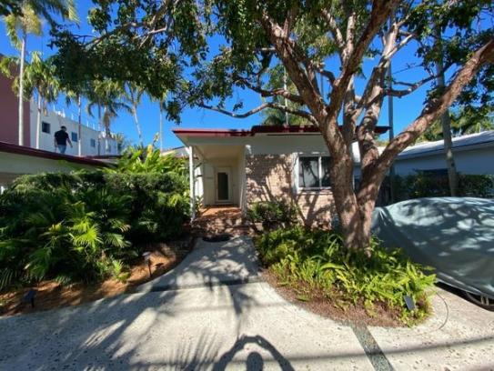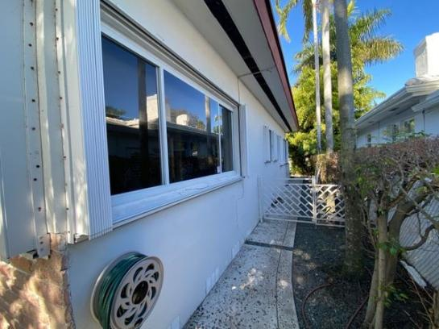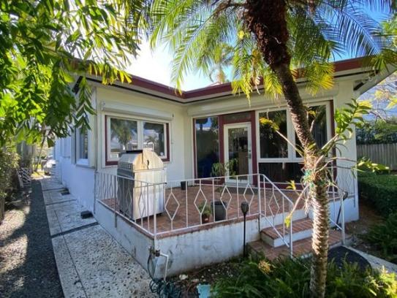

North West West

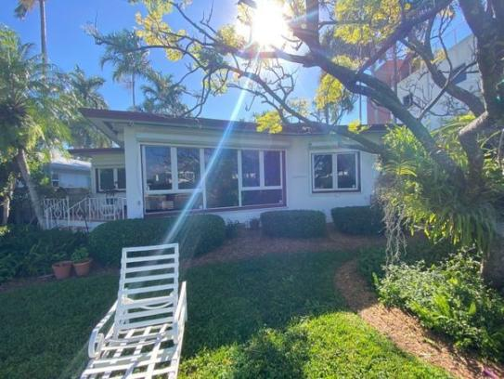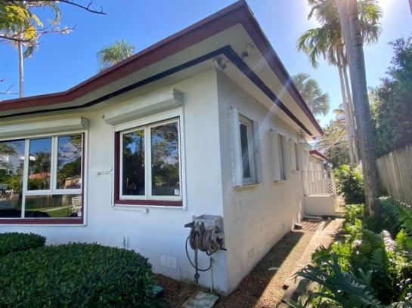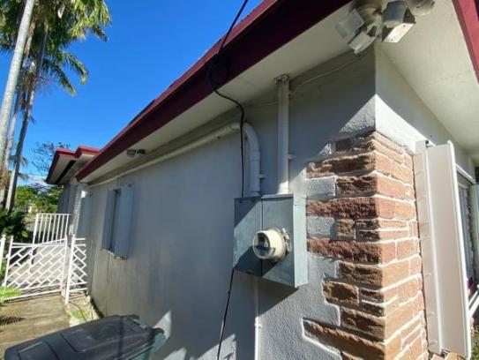

South East

## Electrical System

Panel Photos

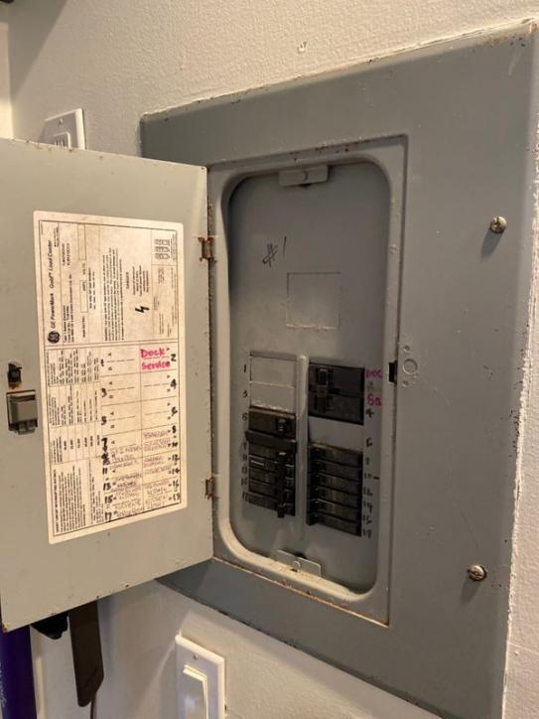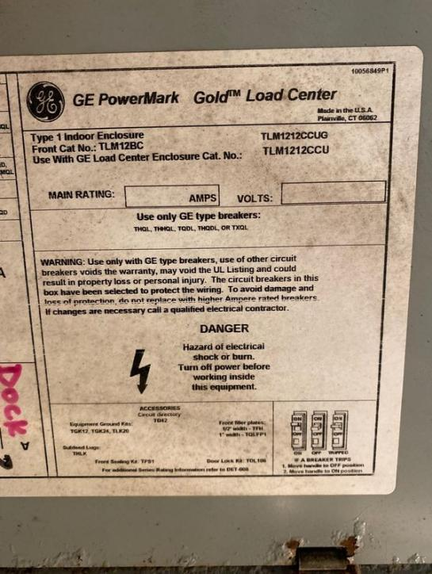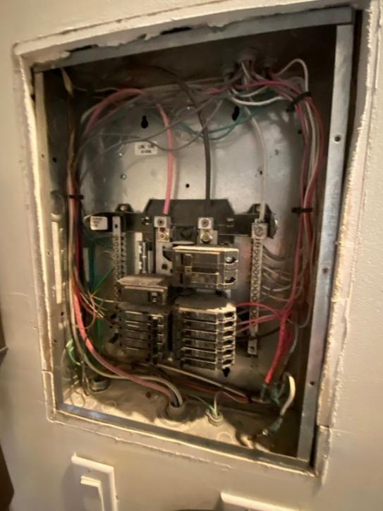

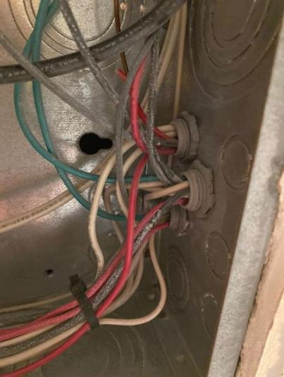

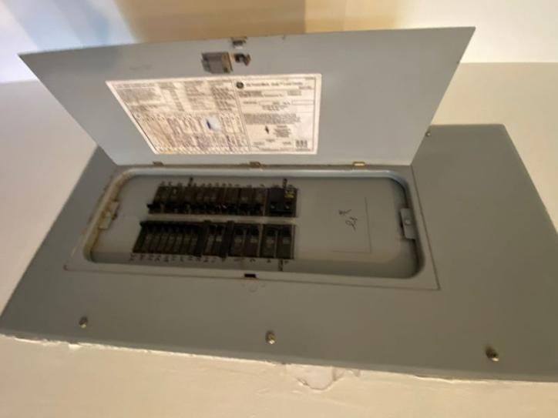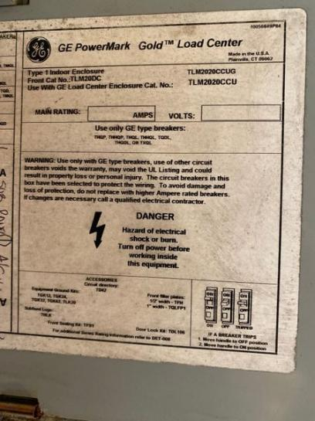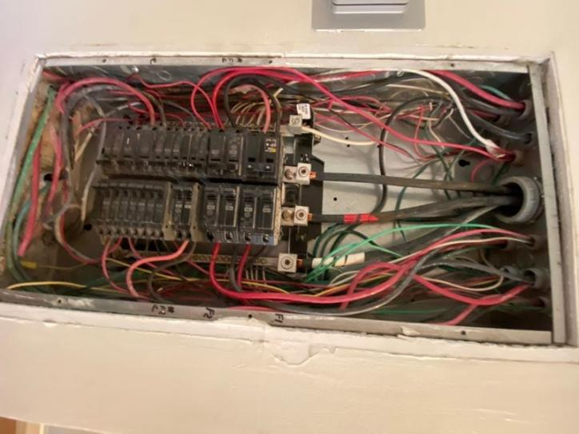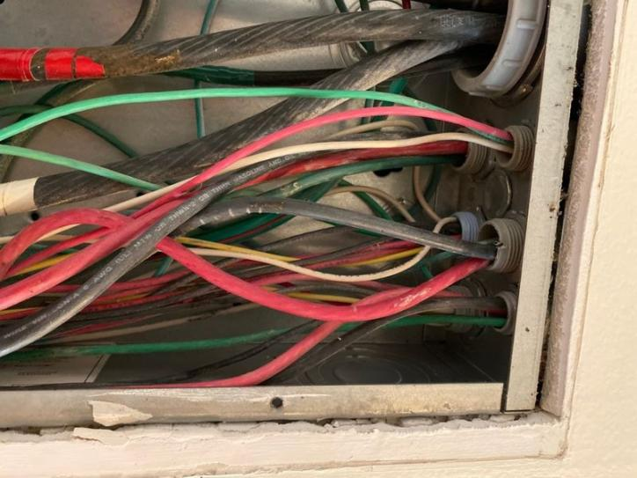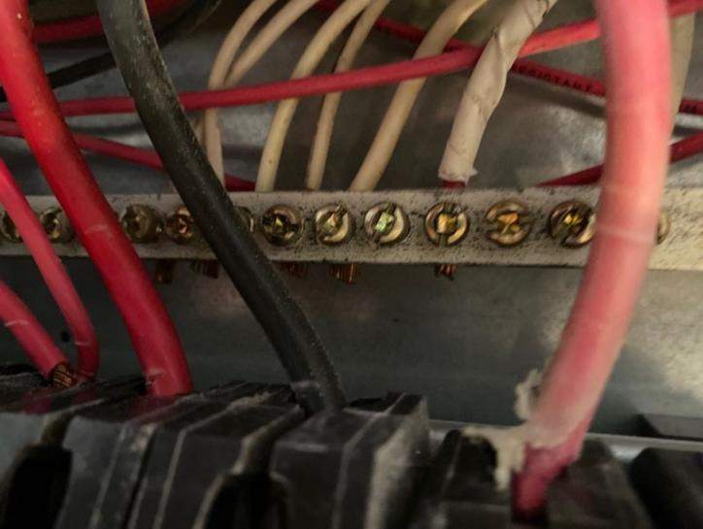

Additional Photos

Hazards

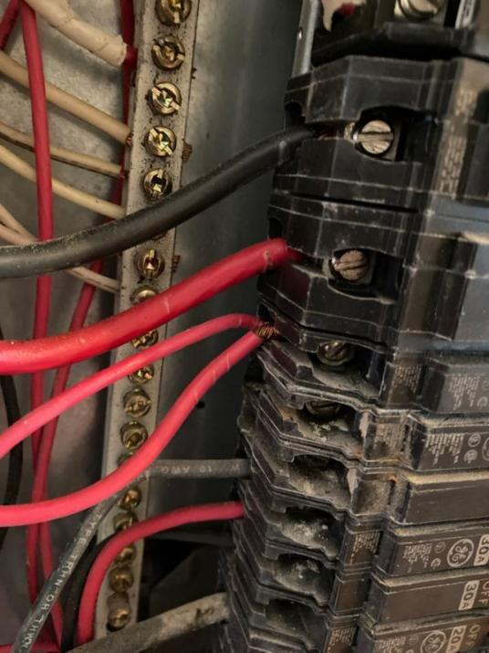

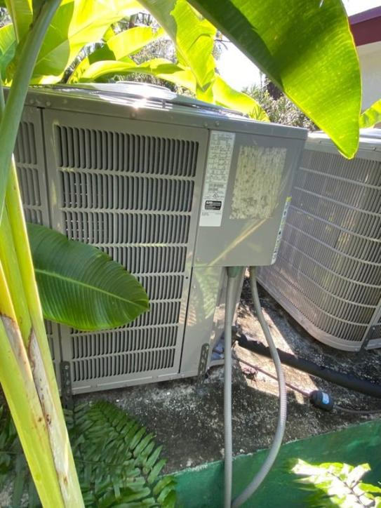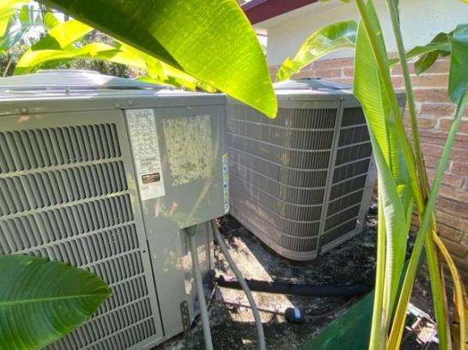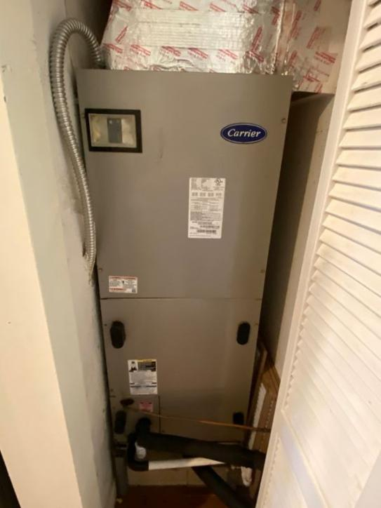

Double tap the breaker and secondary electric panel

## HVAC System

HVAC Equipment

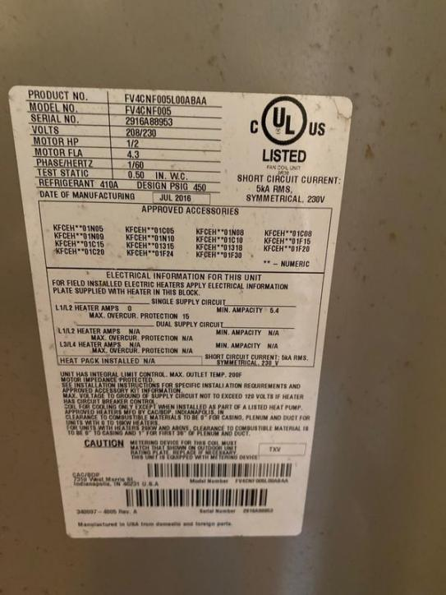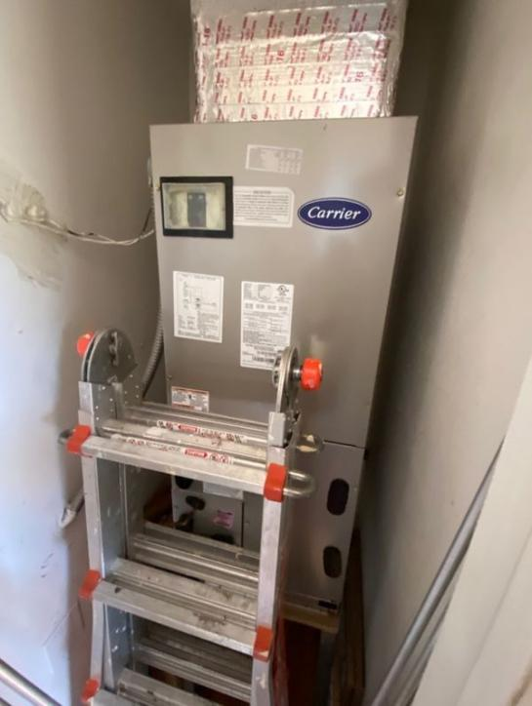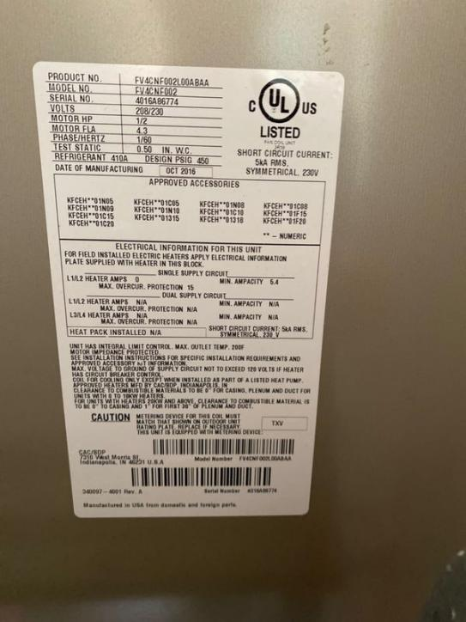

## Plumbing System

Water Heater

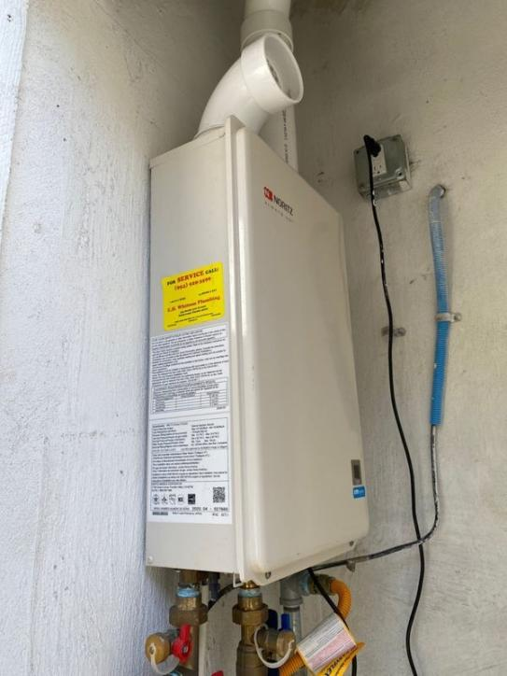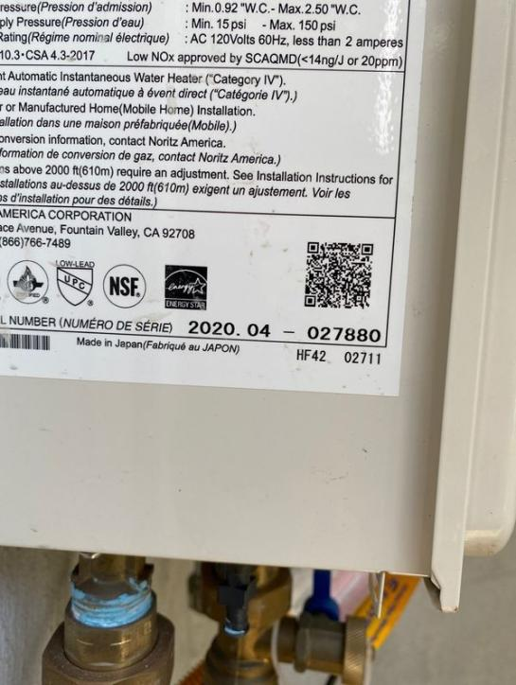

Demand water heater

Under cabinet plumbing & drains

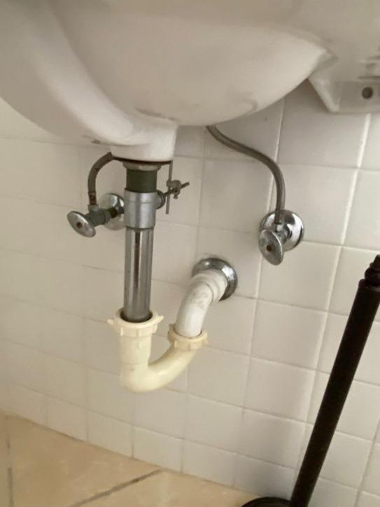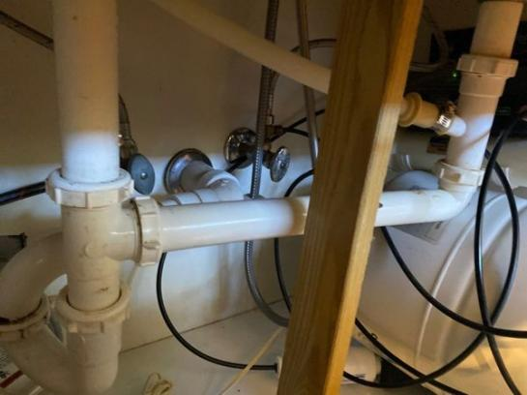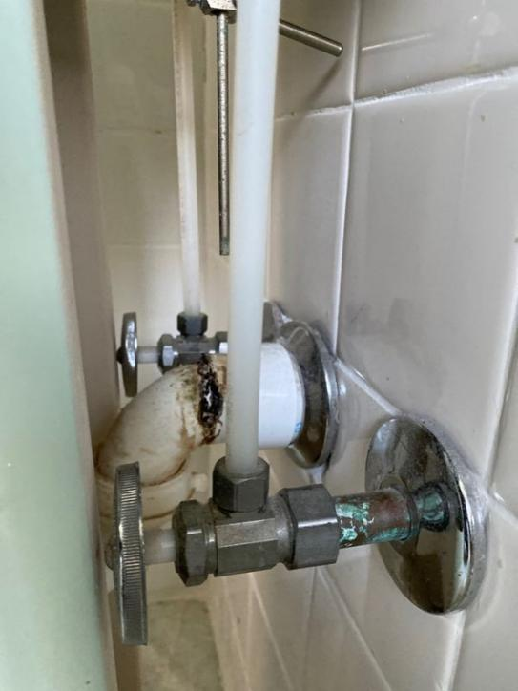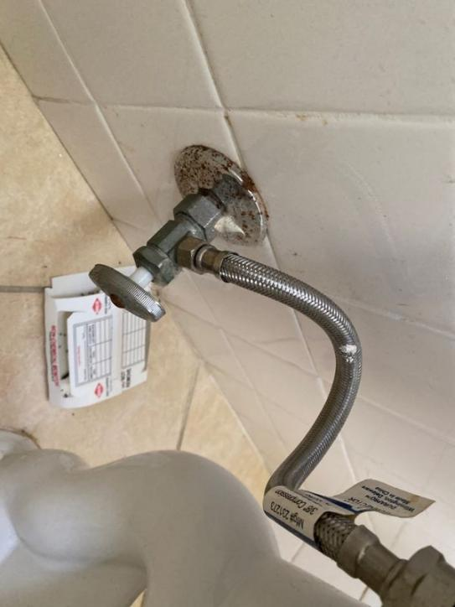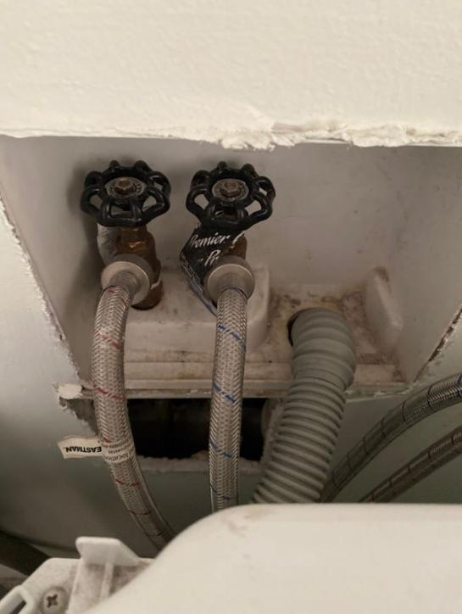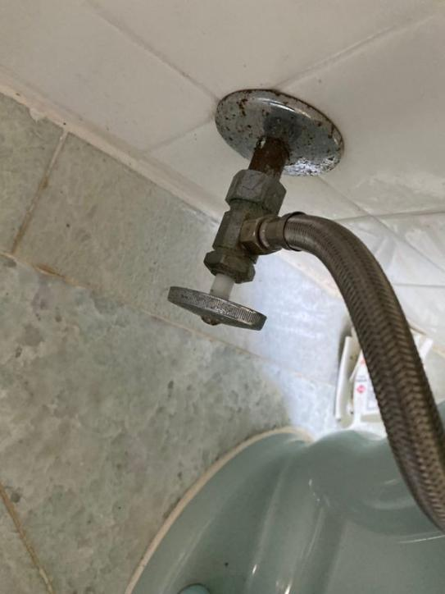

Exposed Valves

## Roof

Photos of Each Slope

**. kJL ..**

(

* *\** . fi T

•• • iv

*Ik* ;.a'V"

*

»»

PPH.

* + 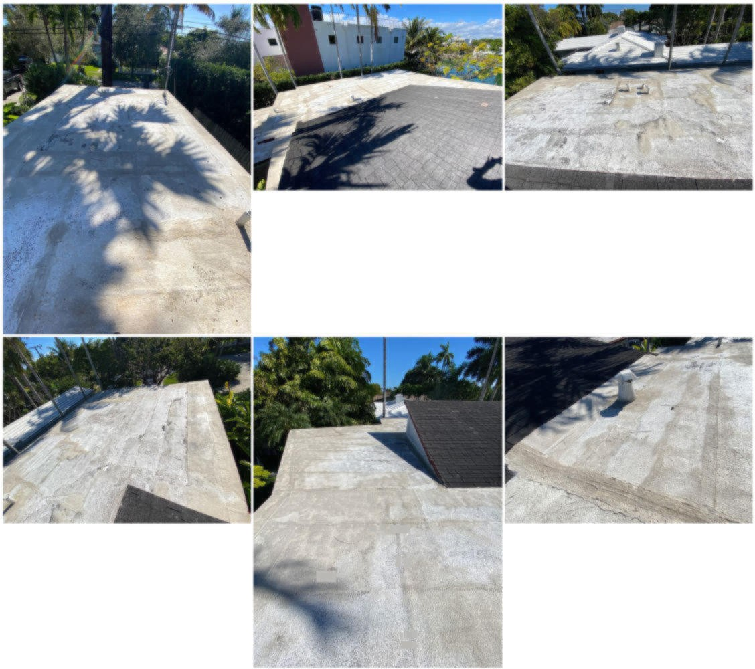*4